# **X6 Series**

BMW X6 Series air suspension systems will provide an excellent and comfortable ride experience for the first 3-5 years after the vehicle leaves the factory. Slowly over time many of the rubber components will start deteriorating. This slow degradation of the rubber components such as Air Springs or Air Struts Rubber Bladders will cause small sometimes barely visible cracks or pinholes that will cause air in the system to slowly escape. When there is an air leak in your BMW X6 Series air suspension system, it can cause the air suspension compressor or other electrical components to over work and burn out. When BMW X6 Series air struts or air spring bags go out, your BMW X6 Series is nearly impossible to drive. BAVARIA CENTER provides many solutions for your air suspension. We offer many Aftermarket Parts, New or Remanufactured, including Air Struts, Air Spring Bags, Compressors, Air Supply Solenoid Valve Blocks and more. Our friendly staff is available to assist you and your satisfaction is our guarantee! You may contact us for any questions or recommendations. We are here to help your BMW X6 Series get back on the road!

# **X6 (E71 / E72) 2008-2014**

# **BMW X6 E71 Air spring air suspension**

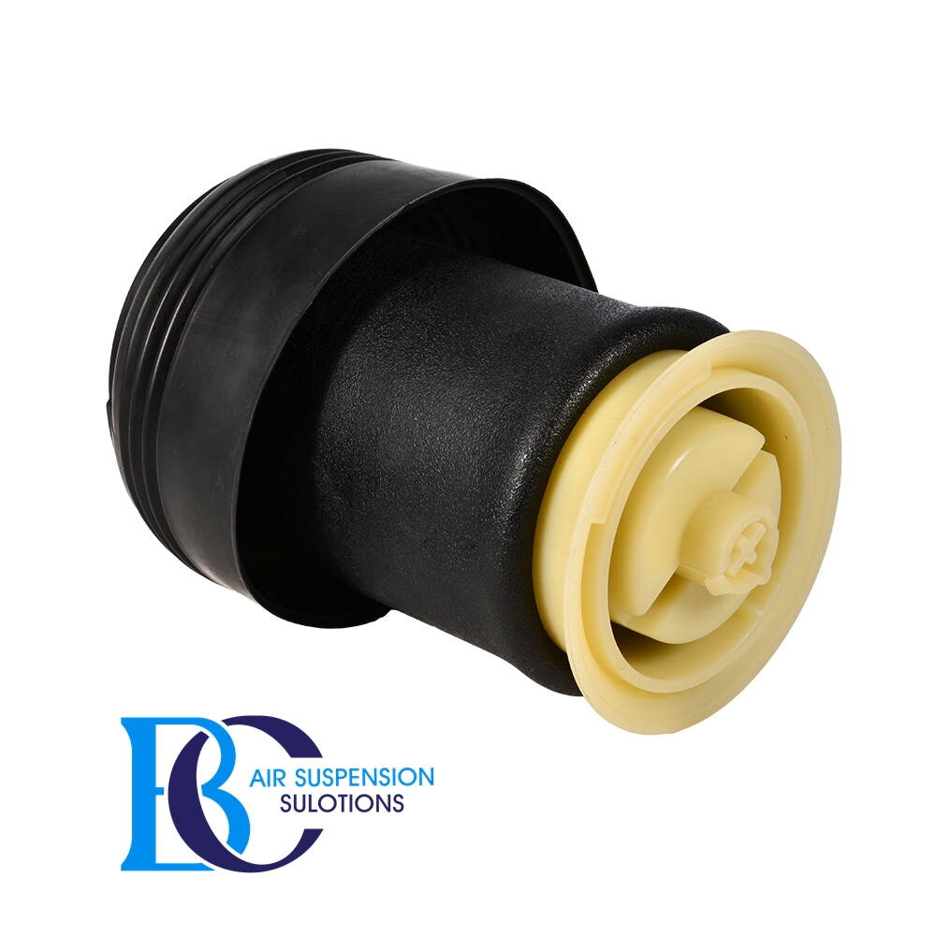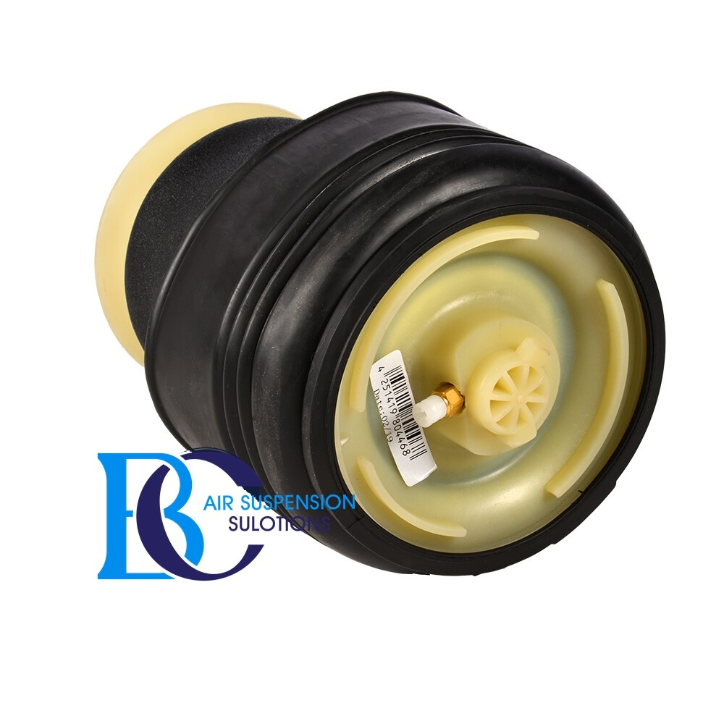

Description

This is an air spring rear side for BMW X6 E71.  
  
 **Can be installed in the following vehicles:** BMW X6 E71 (2006-2010)

**Original spare part number:**

37126790079, 37126774041

# **BMW X6 E71 air Compressor air suspension**

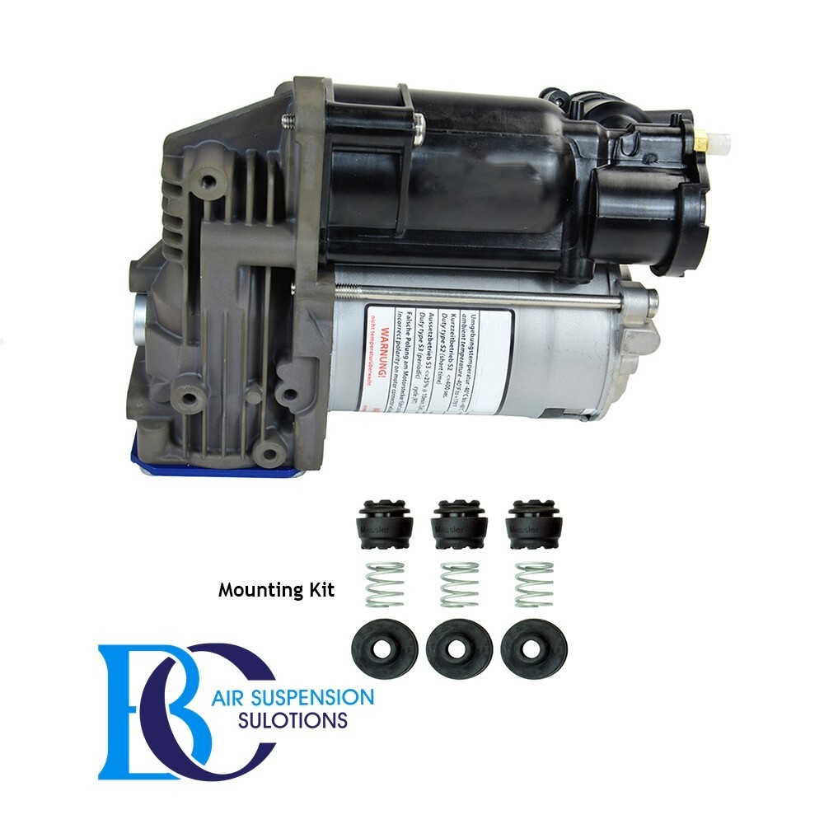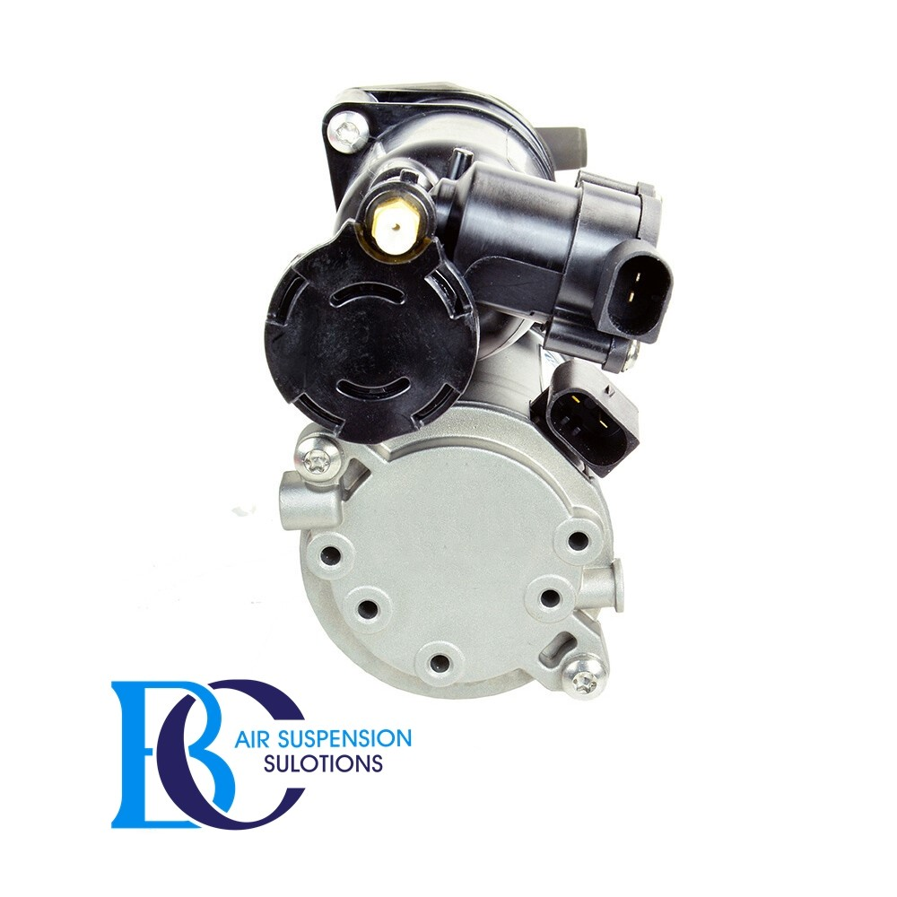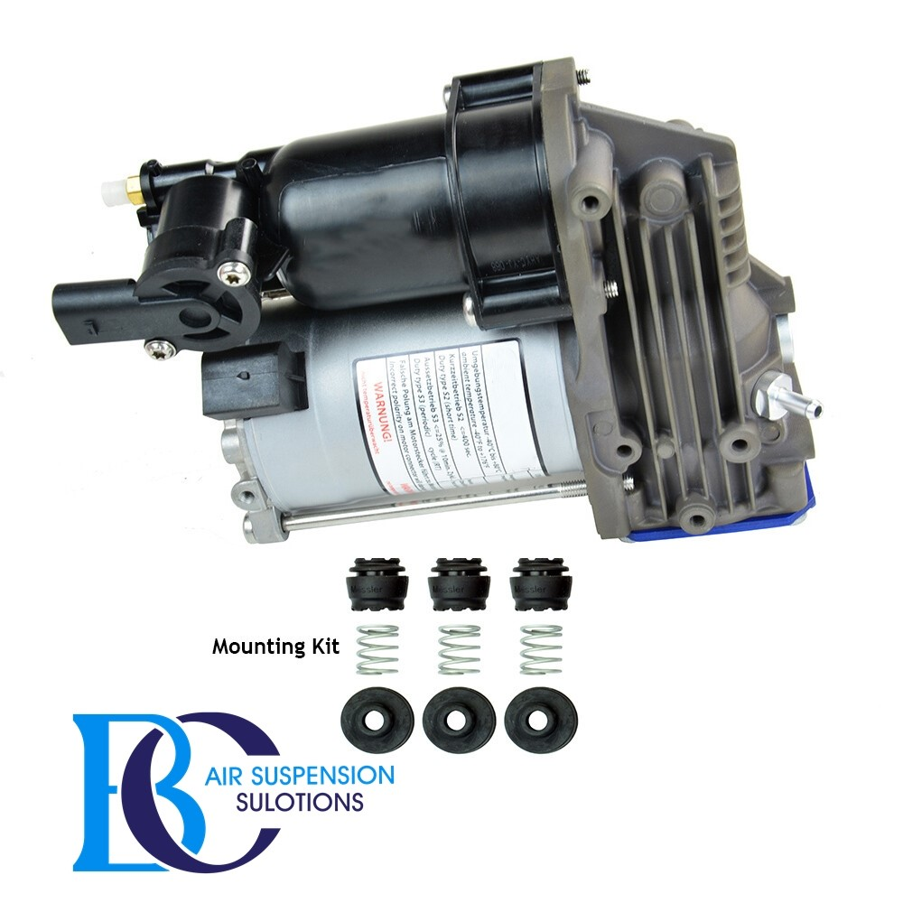

Description

This is air compressor for the BMW X6 E71.

**Can be installed in the following vehicles:**

BMW E71 X6 2008 - 2014

**OEM part number:**

37206859714, 37206799419, 37206789938, 37226785506, 37226775479

# **BMW X6 E72 Valve Air Supply Device Compressor Air Suspension**

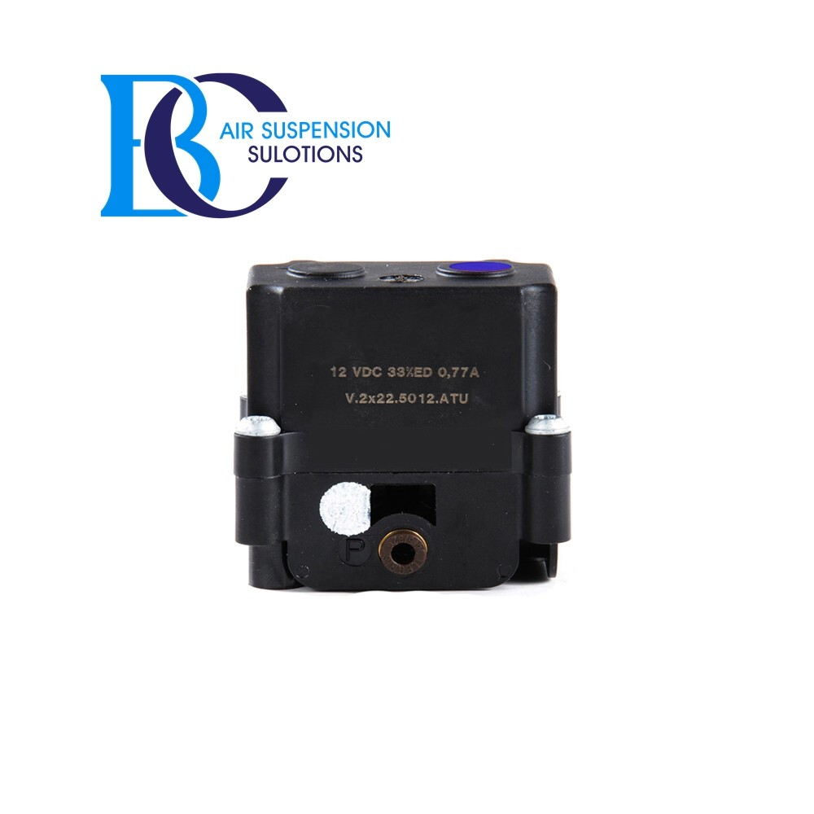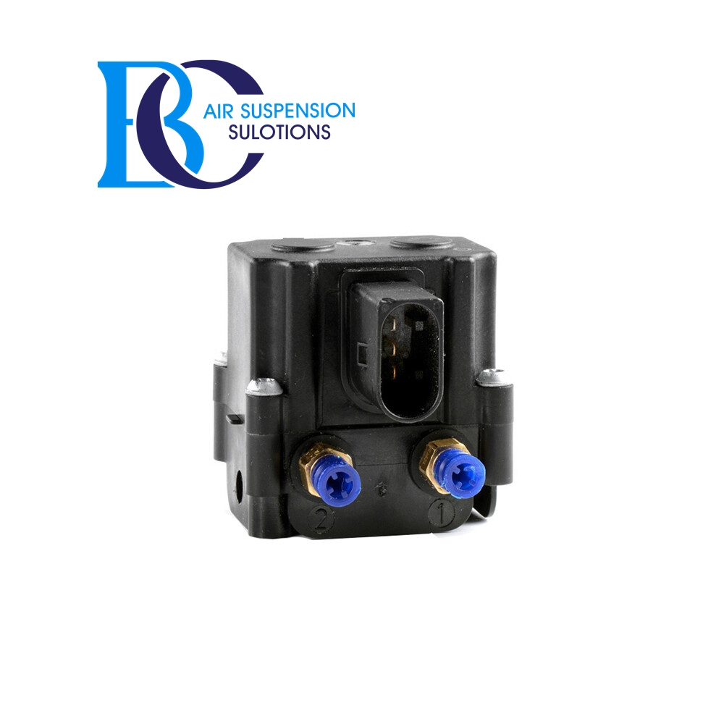

Description

This control valve for the level control for BMW X6 E71.

**Can be installed in the following vehicles:**

BMW X6 E72 (2008 - 2014)

**OEM part number:**

37206859714, 37206799419, 37206789938, 37226785506, 37226775479